1.vote

import java.util.Scanner;

public class Main {

public static void main(String[] args) {

Scanner s = new Scanner(System.in);

System.out.print("Enter your age: ");

if (s.hasNextInt()) {

int age = s.nextInt();

if (age >= 18) {

System.out.println("You are eligible to vote.");

} else {

int yearsLeft = 18 - age;

System.out.println("You are not eligible to vote. You are allowed to vote after " + yearsLeft + " years.");

}

} else {

System.out.println("Invalid input. Please enter a valid age.");

}

}

}

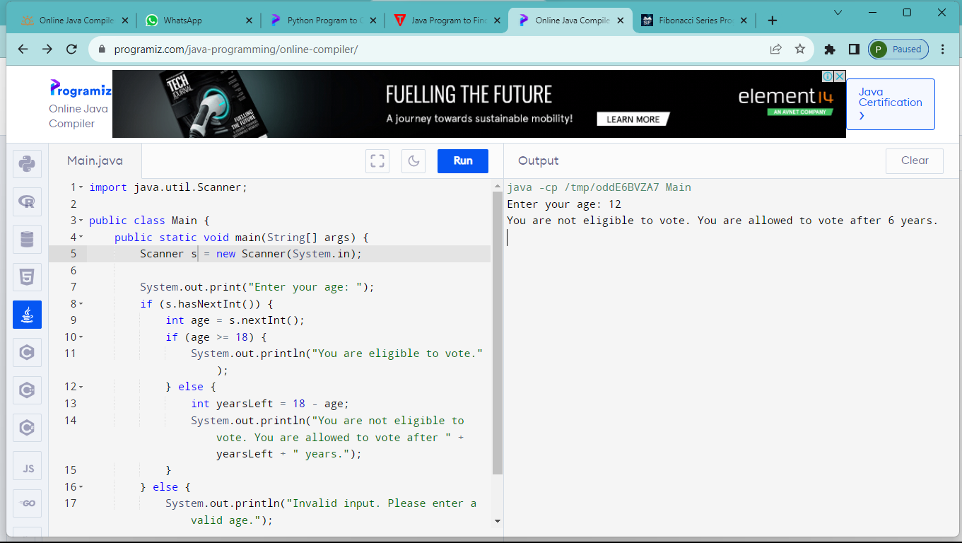

2.string palindrome

import java.util.Scanner;

public class Main {

public static void main(String[] args) {

Scanner s = new Scanner(System.in);

System.out.print("Enter your age: ");

if (s.hasNextInt()) {

int age = s.nextInt();

if (age >= 18) {

System.out.println("You are eligible to vote.");

} else {

int yearsLeft = 18 - age;

System.out.println("You are not eligible to vote. You are allowed to vote after " + yearsLeft + " years.");

}

} else {

System.out.println("Invalid input. Please enter a valid age.");

}

}

}

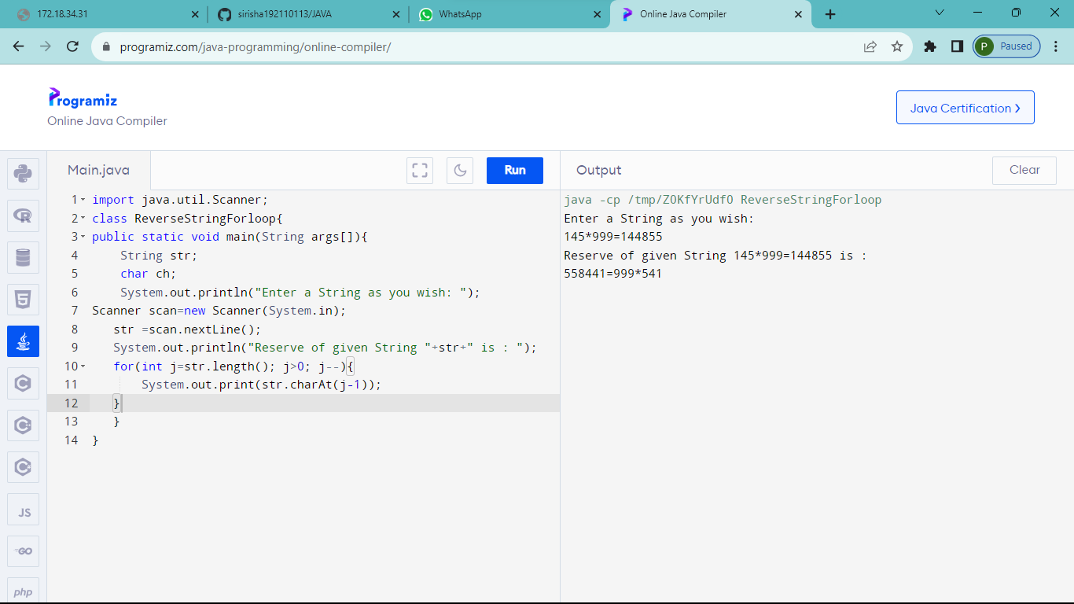

3.user name

import java.util.Scanner;

public class Main {

public static void main(String[] args) {

Scanner scanner = new Scanner(System.in);

System.out.print("Enter the user name: ");

String userName1 = scanner.nextLine();

System.out.print("Reenter the user name: ");

String userName2 = scanner.nextLine();

if ( userName1.equals(userName2)) {

System.out.println("User name is Valid.");

} else {

System.out.println("User name is Invalid.");

}

}

}

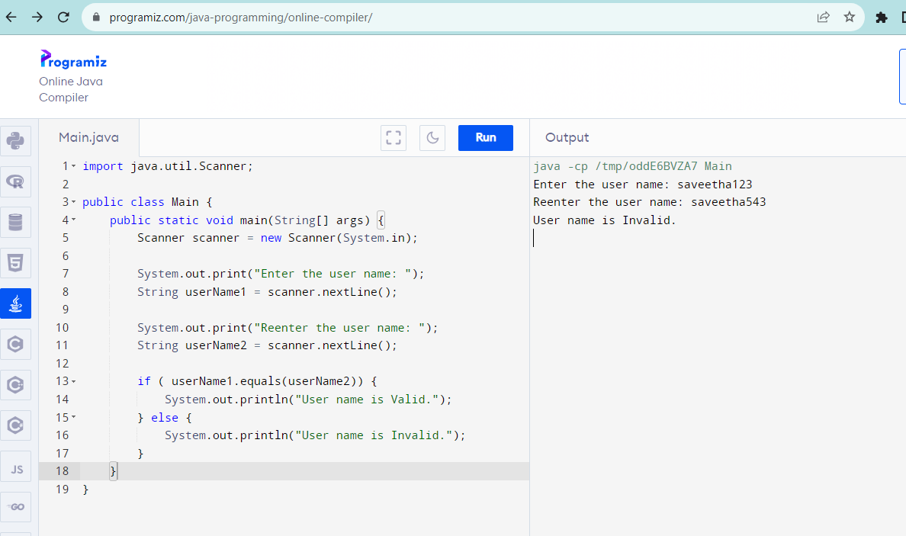

4.Simple interest

import java.util.Scanner;

public class Main {

public static void main(String[] args) {

Scanner scanner = new Scanner(System.in);

System.out.print("Enter the principal amount: ");

double principal = scanner.nextDouble();

System.out.print("Enter the number of years: ");

int years = scanner.nextInt();

System.out.print("Is the customer a senior citizen? (y/n): ");

char isSeniorCitizen = scanner.next().charAt(0);

double rateOfInterest;

if (isSeniorCitizen == 'y' || isSeniorCitizen == 'Y') {

rateOfInterest = 0.12; // 12% interest for senior citizens

} else {

rateOfInterest = 0.10; // 10% interest for others

}

if (principal >= 0 && years >= 0) {

double interest = principal \* rateOfInterest \* years;

System.out.println("Interest: " + interest);

} else {

System.out.println("Invalid input. Please enter valid principal and number of years.");

}

}

}

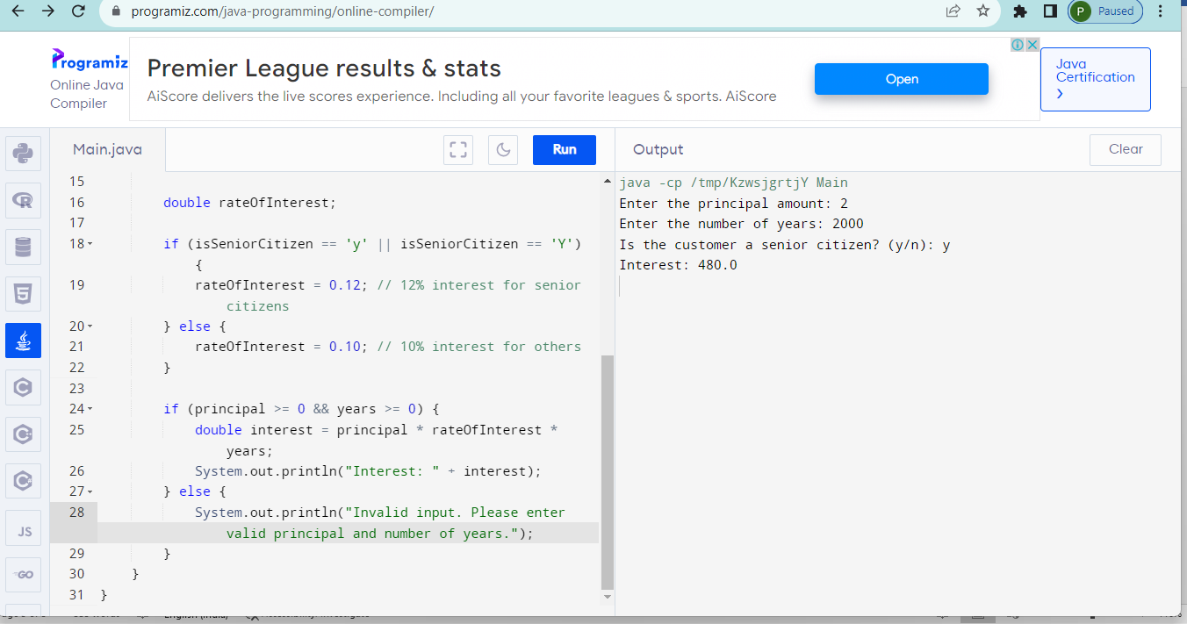

5. import java.util.Scanner;

public class Main {

public static void main(String[] args) {

Scanner scanner = new Scanner(System.in);

System.out.print("Enter the number of days: ");

int days = scanner.nextInt();

if (days >= 0) {

int years = days / 365;

int remainingDays = days % 365;

int weeks = remainingDays / 7;

int remainingDaysInWeeks = remainingDays % 7;

System.out.println("No. of years: " + years);

System.out.println("No. of weeks: " + weeks);

System.out.println("No. of days: " + remainingDaysInWeeks);

} else {

System.out.println("Invalid input. Please enter a non-negative number of days.");

}

}

}

